General Camera Transform Solver

Owen Lu

Electroimpact Inc.

owenl@electroimpact.com

*Abstract*— Assuming an intrinsic camera matrix, the pose of the camera can be estimated by knowing $n$ 3D coordinates and their projections onto the image plane. The previous calibration model assumed that points were within a plane in 3D in order to calculate its relative pose. This meant that for each picture taken in a different orientation, the two transforms must be composed in order to get a relative transform. As this model allows arbitrary 3D points to be used in pose calibration, a set of images of points within multiple non-coplanar checkboards can be used to create a set of points forming a volume in their native tool point coordinate system. That is, no coordinate convention is assumed, and coordinate transforms are direct, resulting in accuracy increases.

# Introduction

It is assumed the $m$ images will be taken in order to calibrate the camera intrinsic matrix which uses the upper right triangular $3×3$

# Conventions and conversion

Dependent on whether the data is stored in rows or columns the transform has a slightly different form. We assume that a vector is a column vector, and thus, the rotation matrix appears to the left of the vector when applying the transform, shown in Eq, 1.

|  |  |
| --- | --- |
| $$x^{'}=Rx+t$$ | (1) |
| $$x={\left[\begin{matrix}x_{1} & x_{2} & x_{3}\end{matrix}\right]}^{T}$$ | (2) |
| $$t={\left[\begin{matrix}t_{1} & t_{2} & t_{3}\end{matrix}\right]}^{T}$$ | (3) |

The reason that this convention is being used is due to explicit solutions given to solve camera intrinsics and extrinsic in the paper using the same convention.

Augmentation of coordinate systems is also common, which allows the transform in Eq. 1 to be applied as one matrix multiplication.

Let $\overline{x}$ be the augmented vector. It follows that the transform can be written as a matrix multiplication as shown in Eq. (5).

|  |  |
| --- | --- |
| $$\overline{x}={\left[\begin{matrix}x_{1} & x_{2} & x_{3} & 1\end{matrix}\right]}^{T}$$ | (4) |
| $$x'=\left[\begin{matrix}R & t\end{matrix}\right]\overline{x}$$ | (5) |

A key point is to notice that although $\overline{x}$ is augmented, after multiplication of the transform matrix, $x'$ is not augmented. Another convention instead of using $\left[\begin{matrix}R & t\end{matrix}\right]$ as the transform matrix is to expand it even further from a $3×4$ matrix into a $4×4$ matrix to keep the augmentation. This allows successive transforms to be applied very easily. An example of such a matrix is shown in Eq. 6.

|  |  |
| --- | --- |
| $$T=\left[\begin{matrix}r_{11} & r_{12} & r_{13} & t_{1} \\ r_{21} & r_{22} & r_{23} & t_{2} \\ r_{31} & r_{32} & r_{33} & t_{3} \\ 0 & 0 & 0 & 1\end{matrix}\right]$$ | (6) |

Therefore, it follows that the augmented transformed vector $\overline{x}'$ can be written as the product of $T$ and $x$.

|  |  |
| --- | --- |
| $${\overline{x}}^{'}=T\overline{x}$$ | (7) |

It is also common for the vectors to be written as row vectors instead of column vectors. Given that we have computed $T$ already, to convert to row vectors we simply need the transpose of $T$.

|  |  |
| --- | --- |
| $${{\overline{x}}^{'}}^{T}={\overline{x}}^{T}T^{T}$$ | (8) |

This allows us to easily convert conventions depending on the implementations in different libraries. Notably, Matrix3D transforms in the standard C# Media3D assembly uses the transform $T^{T}$ convention, which is why the transform must be converted if it is first obtained using the column vector convention.

# Algorithm Summary

Within the C# implementation, it is assumed that the coordinates within a checkerboard frame are known and that the corners of the checkerboard within an image can be detected with the Keyence system. That is, we assume that we have one set of points that have the locations of the corners in a coordinate system, and $n$ sets of points that correspond to the locations of the corners within each image.

The algorithm is then broken down into 4 major steps

1. Initial homography estimation
2. Solve for camera intrinsic matrix
3. Solve for a set of camera extrinsic transforms
4. Combine camera extrinsic transforms with tool-point transforms to solve tool-point to camera transform

These steps are described in detail in the following sections.

# Homography Estimation

Due to the checkerboard pattern being contained within a plane, we can define a coordinate system that makes all checkerboard corners have Z coordinate equal to zero. Originally the equation that maps 3D points onto the 2D image is in Eq. 9.

|  |  |
| --- | --- |
| $$s\left[\begin{matrix}u \\ v \\ 1\end{matrix}\right]=A\left[\begin{matrix}r_{1} & r_{2} & r_{3} & t\end{matrix}\right]\left[\begin{matrix}x \\ y \\ z \\ 1\end{matrix}\right]$$ | (9) |

However, since $Z=0$, column $r_{3}$ of the rotation matrix can be removed for the analysis. Therefore, we can relate the vector on the left with an augmented 2D vector ${\left[\begin{matrix}X & Y & 1\end{matrix}\right]}^{T}$ on the right via homography $H$.

|  |  |
| --- | --- |
| $$\left[\begin{matrix}u \\ v \\ 1\end{matrix}\right]=H\left[\begin{matrix}x \\ y \\ 1\end{matrix}\right]$$ | (10) |
| $$H=A\left[\begin{matrix}r_{1} & r_{2} & t\end{matrix}\right]$$ | (11) |

Writing $H$ in terms of its individual entries gives Eq. 12. Note that $H$ is only unique up to scale.

|  |  |
| --- | --- |
| $$H=\left[\begin{matrix}H_{11} & H_{12} & H_{13} \\ H_{21} & H_{22} & H_{23} \\ H_{31} & H_{32} & H_{33}\end{matrix}\right]$$ | (12) |

From Eq. 10 and Eq. 12, we can rewrite the equations for pixel coordinates $u$ and $v$.

|  |  |
| --- | --- |
| $$u=\frac{xH_{11}+yH_{12}+H_{13}}{xH_{31}+yH_{32}+H_{33}}$$ | (13) |
| $$y=\frac{xH_{21}+yH_{22}+H_{23}}{xH_{31}+yH_{32}+H_{33}}$$ | (14) |

Let $h$ be the listed elements of $H$ in row major order.

|  |  |
| --- | --- |
| $$h={\left[H_{12},H_{12},H_{13},H_{21},H_{22},H_{23},H_{31},H_{32},H_{33}\right]}^{T}$$ | (15) |

Then Eq. 13 and Eq. 14 can be written as two homogeneous equations using $h$.

Let

|  |  |
| --- | --- |
| $$g_{x}=\left[-x,-y,-1,0,0,0,ux,uy,u\right]$$ | (16) |
| $$g_{y}=\left[0,0,0,-x,-y,-1,vx,vy,v\right]$$ | (17) |
| $$g_{x}h=0$$ | (18) |
| $$g_{y}h=0$$ | (19) |

Therefore, for each pair of points $(u,v)$ and $(x,y)$ we get 2 equations. Since each point gives two equations, we can construct the matrix $G$ which concatenates all of the equations by stacking them vertically.

Matrix $G$ must thenbe a $2n×9$ matrix where $n$ is the number of coordinate pairs. This formulates a homogenous system of equations.

|  |  |
| --- | --- |
| $$Gh=0$$ | (20) |

At this point, Singular Value Decomposition (SVD) is used to solve for the least squares solution to $h$ which is returned as the right hand singular vector associated with the smallest singular value $σ_{9}$.

# Intrinsic Estimation

The basic principle behind intrinsic estimation is that each image taken will result in 2 constraints on the intrinsic parameters of the camera. Taking a sufficient number of pictures allows the intrinsic matrix to be solved. The derivation is not shown here, but the method to construct constraint matrix $V$ to solve transformed variables $b$, which can be used to calculate intrinsic matrix $A$, is given.

Let $v_{ij}$ be calculated as below from estimated homography $H$.

|  |  |
| --- | --- |
| $$v_{ij}={\left[\begin{matrix}H_{1i}H_{1j} \\ H_{1i}H_{2j}+H_{2i}H_{1j} \\ H_{2i}H_{2j} \\ H_{3i}H_{1j}+H_{1i}H_{3j} \\ H_{3i}H_{2j}+H_{2i}H_{3j} \\ H_{3i}H_{3j}\end{matrix}\right]}^{T}$$ | (21) |

Then $V$ can be formulated by stacking 2 equations for each of the $m$ images taken. Therefore, $V$ is a $2m×6$ matrix.

|  |  |
| --- | --- |
| $$\left[\begin{matrix}v_{12} \\ v_{11}-v_{12}\end{matrix}\right]b=0$$ | (22) |

We need at least 3 images in order to have a unique solution to $b$ up to scale.

|  |  |
| --- | --- |
| $$b={\left[b_{1},b_{2},b_{3},b_{4},b_{5},b_{6}\right]}^{T}$$ | (23) |

The intrinsic matrix **A** is a $3×3$ that maps 3D points onto the 2D image pixels.

|  |  |
| --- | --- |
| $$A=\left[\begin{matrix}α & γ & u_{0} \\ 0 & β & v_{0} \\ 0 & 0 & 1\end{matrix}\right]$$ | (24) |

Each parameter in $A$ can then be calculated from $b$. From Zhang’s paper w,e have the following formulae for the parameters which should be calculated in the same sequence.

|  |  |
| --- | --- |
| $$v_{0}=\frac{\left(b_{2}b_{4}-b_{1}b_{5}\right)}{b_{1}b_{3}-b_{2}^{2}}$$ | (25) |
| $$ϕ=b_{6}-\frac{\left(b_{4}^{2}-v_{0}\left(v_{2}b_{4}-b_{1}b_{5}\right)\right)}{b_{1}}$$ | (26) |
| $$α=\sqrt{\frac{ϕ}{b_{1}}}$$ | (27) |
| $$β=\sqrt{\frac{ϕb_{1}}{b_{1}b_{3}-b_{2}^{2}}}$$ | (28) |
| $$γ=-\frac{b_{2}α^{2}β}{ϕ}$$ | (29) |
| $$u_{0}=\frac{γu_{0}}{α}-\frac{b_{4}α^{2}}{ϕ}$$ | (30) |

At this point matrix, $A$ can be solved via substitution.

# Extrinsic Estimation

Now that $A$ is known it is a straightforward calculation to find the rotation and translation matrices defined in Eq. 9.

Let

|  |  |
| --- | --- |
| $$R=[\begin{matrix}r_{1} & r_{2} & r_{3}\end{matrix}]$$ | (31) |
| $$H=[\begin{matrix}h_{1} & h_{2} & h_{3}\end{matrix}]$$ | (32) |

Let $C=\frac{A^{-1}}{\left\|A^{-1}h_{1}\right\|}=\frac{A^{-1}}{\left\|A^{-1}h_{2}\right\|}$

|  |  |
| --- | --- |
| $$r_{1}=Ch_{1}$$ | (33) |
| $$r_{2}=Ch_{2}$$ | (34) |
| $$r_{3}=r_{1}×r_{2}$$ | (35) |
| $$t=Ch_{3}$$ | (36) |

At this point, we have all the parameters to construct transformation matrix $T$ in Eq. 6.

# Combining tool point transforms

The purpose of performing this calibration method was to find the transform from the tool-point to the camera. Up to this point, the algorithm has found the rotation and translation of the camera relative to the checkerboard coordinates. In our application, the checkerboard is located in space and thus, the transform to convert a point from the checkerboard coordinates to the tool-point and vice-versa is assumed to be known.

Thus, the process is to find the aggregate transform from tool-point to checkerboard to camera $m$ times and average the transform.

Suppose we have two transforms defined by $R_{1},t_{1}$ and $R_{2},t_{2}$ applied in sequence.

Then the aggregate transform has the following properties

|  |  |
| --- | --- |
| $$T_{a}=[\begin{matrix}R_{2}R_{1} & R_{2}t_{1}+t_{2}\end{matrix}]$$ | (37) |

Then all we must do is compute the aggregate rotation matrix and translation as in Eq. 37 to find the aggregate transform from tool-point to the camera.

# Averaging multiple transforms

The concept of averaging, in this case, means the following. Suppose $\overline{p}$ is a point that we wish to transform by $T_{a}$. Since there are $m$ estimates of $T_{a}$ we need to average them.

|  |  |
| --- | --- |
| $${\overline{p}}_{i}^{'}={T_{a}}_{i}\overline{p}$$ | (38) |

An easy method would simply be to add all the estimations of $p_{i}$ and average them.

|  |  |
| --- | --- |
| $${\overline{p}'}_{avg}=\frac{1}{m}\sum_{i=1 }^{m}{{\overline{p}}_{i}^{'}}=\frac{1}{m}\left(\sum_{i=1 }^{m}{{\overline{T_{a}}}_{i}^{'}}\right)\overline{p}$$ | (39) |

This means that the averaged transformed can be thought of as adding all the transforms element by element and averaging them.

# Rotation Matrix Correction

Due to estimation error, the rotation matrix component found by averaging in Eq. 39 will not, in general, satisfy the rotation matrix. We then find the matrix that satisfies both the properties of the rotation matrix and minimizes the Frobenius norm .

|  |  |
| --- | --- |
|  | (40) |

This can be done also with the SVD. Suppose we use SVD to obtain matrices $UΣV^{T}$, then the expression for the best fit rotation matrix can be calculated using $UV^{T}$.

|  |  |
| --- | --- |
| $$R_{avg}=UΣV^{T}$$ | (41) |
| $$R_{c}=UV^{T}$$ | (42) |

If the rotation matrix $R_{c}$ is improper, then use a negative left singular vector $u_{3}$ in order to computer $R_{c}$.

# Camera calibration results

Using a phone camera, 4 images of a checkerboard were taken. This is shown in Figure 1.

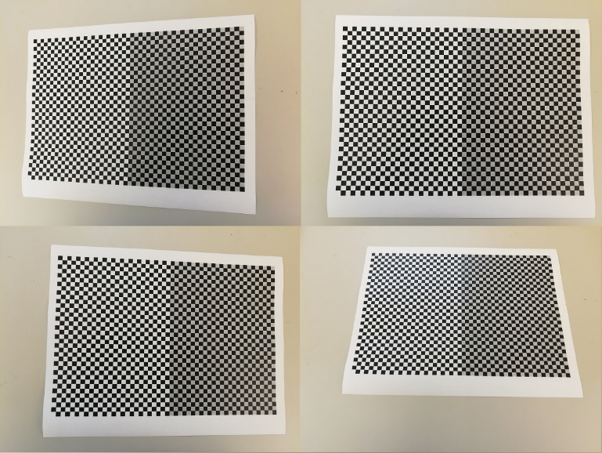

Figure 1 – All 4 images used to calibrate the camera.

Since matrices $A$, $[R t]$ can be calculated, we can apply the transforms on the checkerboard corners and also compare them to the image points. We simply multiply the matrices to a $4×n$ matrix containing the data points. This is shown in Eq, 43.

|  |  |
| --- | --- |
| $$\left[\begin{matrix}u_{1}' & … & u_{n}' \\ v_{1}' & … & v_{n}' \\ w_{1}' & … & w_{n}'\end{matrix}\right]=A\left[R t\right]\left[\begin{matrix}x_{1} & … & x_{n} \\ y_{1} & … & y_{n} \\ 0 & 0 & 0 \\ 1 & 1 & 1\end{matrix}\right]$$ | (43) |

Since there is an arbitrary scale $w_{i}'$ we simply divide $u_{i}'$ and $v_{i}'$ by the scale $w_{i}'$ for each point. This gives the pixel coordinates on the image. Using this method, a reprojection was created, showing good agreement in Figure 2.

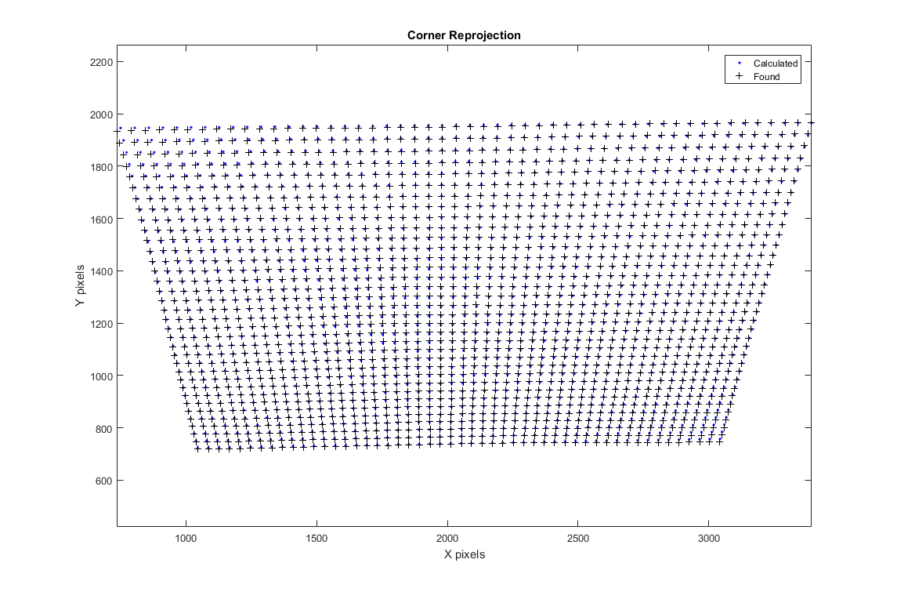

Figure 2 - Reprojection verification

# Conclusion

Although we are primarily concerned with estimating the matrix $[R t]$, looking at the pixel reprojection errors can give us insight on how well this model in general is performing. Thus, we considered the norm of the errors and their distribution as well as their mean. From Figure 3 we can see each pixel axis has a mean error centered around 0. In practice i,t is approximately 0.4 pixels mean error in each axis.

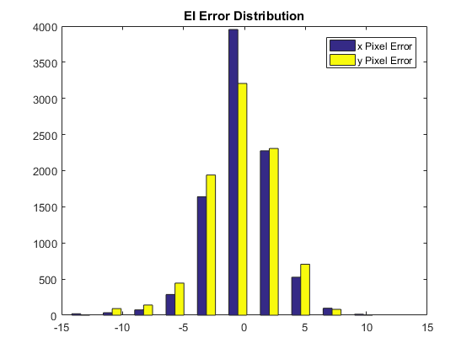

Figure 3 - Histogram of $u$ and $v$ pixel error for all 4 images

The Euclidian error is calculated shown in Eq. 46. It uses the standard deviations in each of the axes.

|  |  |
| --- | --- |
| $$e_{u}=std(u^{'}-u)$$ | (44) |
| $$e_{v}=std(v^{'}-v)$$ | (45) |
| $$δ=\sqrt{e_{v}^{2}+e_{u}^{2}}≈4$$ | (46) |

The result is 4 pixel standard deviation error showing good agreement. This shows the validity of the calibration procedure in producing accurate results and that the transforms are valid over multiple angles.